Full Stack Development with MERN
Project Documentation format
- INTRODUCTION
Project Title: Calculating family expenses
Team ID : LTVIP2026TMIDS66350

Team Size : 4

Team Leader : Syed Abdul Subhan

Team member : Kammari Srikanth Achari

Team member : Nagamuthi Sashi Ram

Team member : Thuggali Nagaraju
1.1 Project Overview
The Family Expense Management System is a web-based application developed on the ServiceNow platform to track, categorize, and report daily and monthly family expenses. The system allows family members to log expenses, automatically aggregates totals, and generates detailed reports.
1.2 Purpose
- To help families track their spending accurately and efficiently.
- To provide automated expense summaries by date, member, and category.
- To enable better budgeting and financial decision-making for family households.

2. IDEATION PHASE
2.1 Problem Statement
- Family members often lose track of daily expenses due to manual recording in notebooks.
- Head of the family cannot monitor overall spending in real-time.
- Difficulty in generating accurate reports for budgeting and analysis.
2.2 Empathy Map Canvas
- Family members feel disorganized and worried about overspending.
- Parents want control and visibility over each member’s spending.
- System should provide real-time updates and easy reporting.
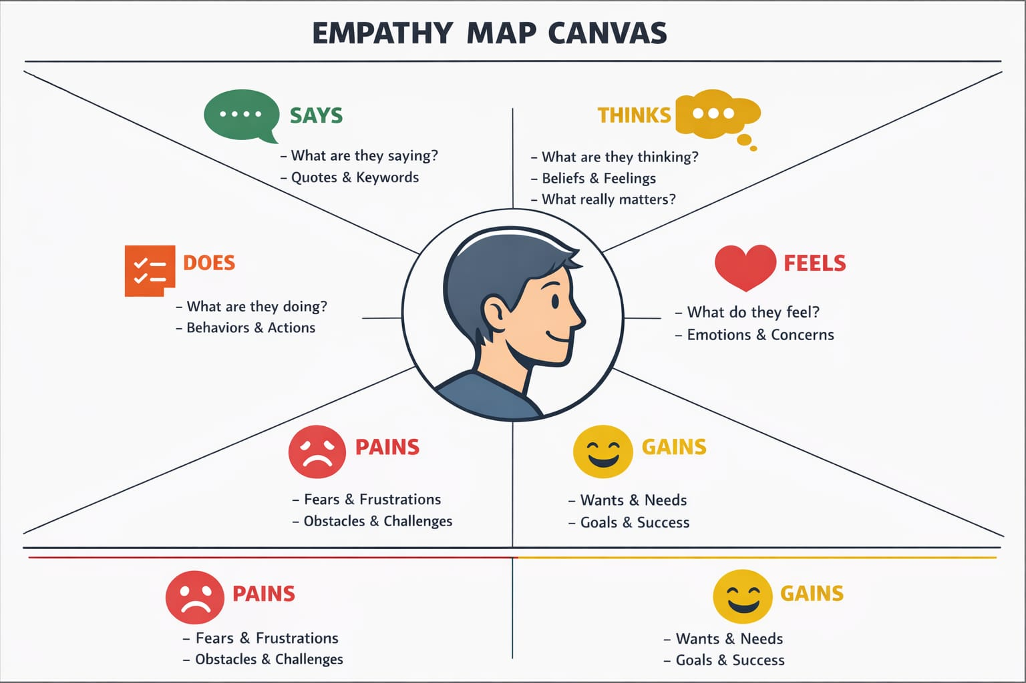
2.3 Brainstorming
- Centralized expense tracking database.
- Auto-calculation of daily and monthly totals.
- Member-wise categorization of expenses.
- Dashboard with charts and filters.
- Automated reporting to generate insights.

3. REQUIREMENT ANALYSIS
3.1 Customer Journey Map
- Family members submit expenses → Expenses stored in Daily Expenses table → Automated aggregation in Family Expenses table → Reports/dashboard provide insights.
3.2 Solution Requirement
Functional Requirements (FRs)
FR No | Functional Requirement | Sub Requirement
FR-1 | User Registration | Register via Form, Gmail
FR-2 | User Authentication | Email & OTP verification
FR-3 | Expense Management | Add, Update, Delete Expenses
FR-4 | Expense Viewing | View daily/monthly totals
FR-5 | Reporting | Generate member-wise/category-wise reports

Non-Functional Requirements (NFRs)
NFR No | Non-Functional Requirement | Description
NFR-1 | Usability | Simple, user-friendly interface
NFR-2 | Security | Protect sensitive data and ensure integrity
NFR-3 | Reliability | Consistent performance without failures
NFR-4 | Performance | Fast updates and calculations
NFR-5 | Availability | Accessible at all times during use
NFR-6 | Scalability | Can handle multiple family members and large datasets
3.3 Data Flow Diagram (DFD)
- Family members → Input daily expense → Processed by Business Rules → Aggregated totals in Family Expenses table → Dashboard / Reports
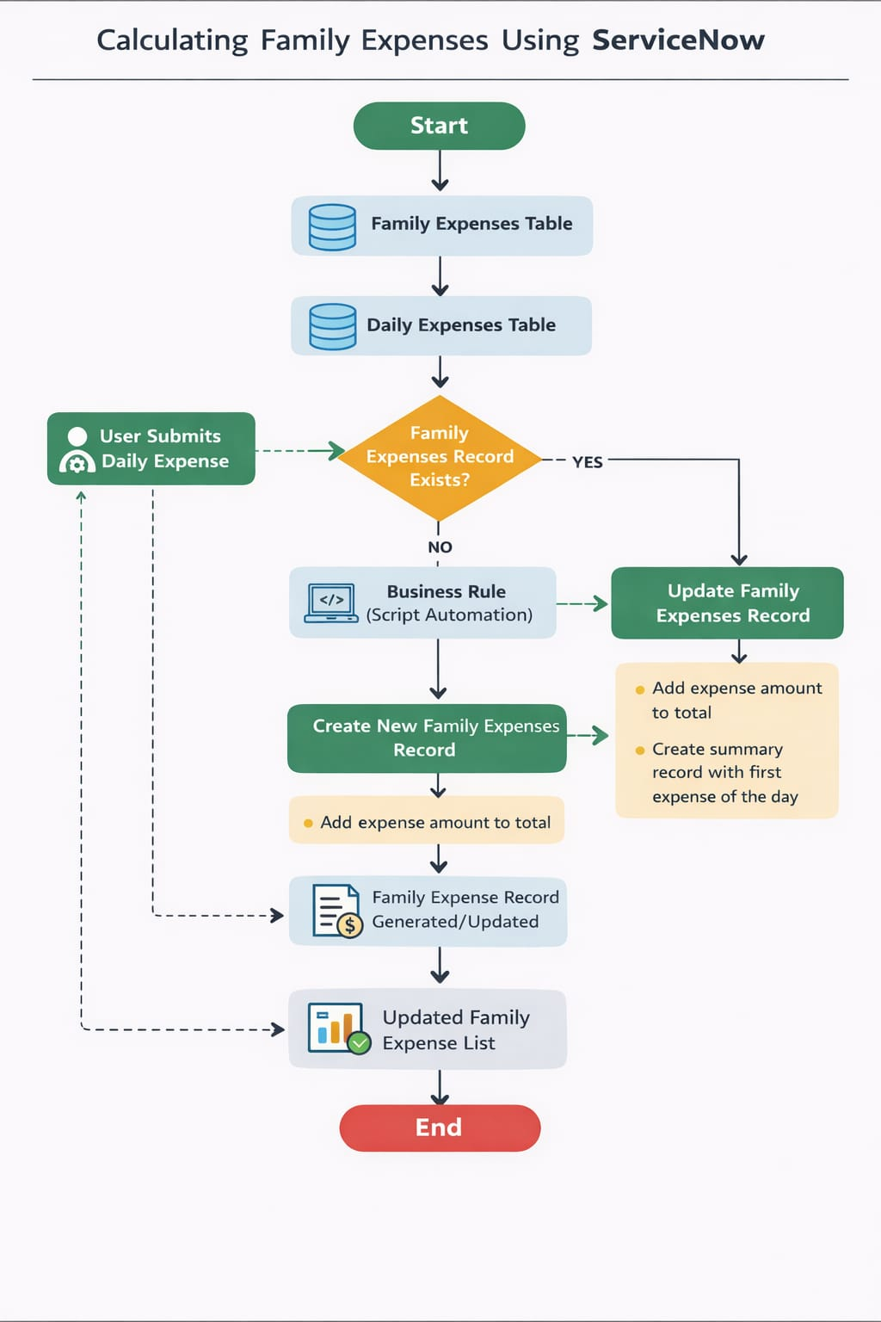
3.4 Technology Stack
Component | Technology
Platform | ServiceNow
UI | ServiceNow Forms & List Views
Database | ServiceNow Tables: Daily Expenses, Family Expenses
Logic | Business Rules & GlideRecord Scripts
Reporting | ServiceNow Reports & Dashboards

4. PROJECT DESIGN
4.1 Problem-Solution Fit
Traditional manual tracking causes errors, missing records, and lack of insight. The proposed system provides real-time, automated aggregation, member-wise tracking, and reporting, reducing errors and improving financial visibility.
4.2 Proposed Solution
- Daily Expenses Table: Records each expense with member, amount, category, and comments.
- Family Expenses Table: Aggregates total expenses per day.
- Business Rules: Automatically update totals when a new expense is added.
- Dashboard: Filters, graphs, and reports for daily/monthly spending.
4.3 Solution Architecture
- UI Layer: ServiceNow forms and dashboards
- Logic Layer: GlideRecord scripts, Business Rules for automation
- Data Layer: Daily Expenses & Family Expenses tables
- Reporting Layer: Real-time dashboards and automated reports

5. PROJECT PLANNING & SCHEDULING
5.1 Product Backlog & Sprint Schedule
Sprint | Functional Requirement (Epic) | User Story Number | User Story / Task | Story Points | Priority | Team Members
Sprint-1 | Expense Entry & Viewing | USN-1 | As a family member, I want to add daily expenses | 2 | High | Team
Sprint-1 | Expense Entry & Viewing | USN-2 | View daily totals per member | 1 | High | Team
Sprint-2 | Dashboard & Filtering | USN-3 | Apply category and member filters | 2 | Medium | Team
Sprint-2 | Dashboard & Filtering | USN-4 | Generate daily/weekly report | 3 | High | Team
Sprint-3 | Admin Control | USN-5 | Admin edits/deletes expenses | 3 | High | Team
Sprint-3 | Admin Control | USN-6 | View consolidated Family expenses | 2 | High | Team

Velocity & Burndown
- Average Velocity: 16 Story Points per sprint (based on completed tasks).
- Burndown chart tracks remaining story points vs time for sprint progress.

6. FUNCTIONAL AND PERFORMANCE TESTING
6.1 Performance Testing
Test Case ID | Test Scenario | Expected Result | Actual Result | Pass/Fail
TC-001 | Add Daily Expense | Expense recorded correctly in Daily Expenses | Passed | Pass
TC-002 | Auto-aggregation | Family Expenses table updates total automatically | Total updated in 2s | Pass
TC-003 | Category filter | Filters display only selected category | Works as expected | Pass
TC-004 | Member-wise filter | Filters display only selected member | Works as expected | Pass
TC-005 | Report generation | Generates daily/monthly reports accurately | Report matches table totals | Pass
TC-006 | Offline resilience | Shows cached data or warning when offline | Offline entry not saved | Fail

7. RESULTS
7.1 Output Screenshots
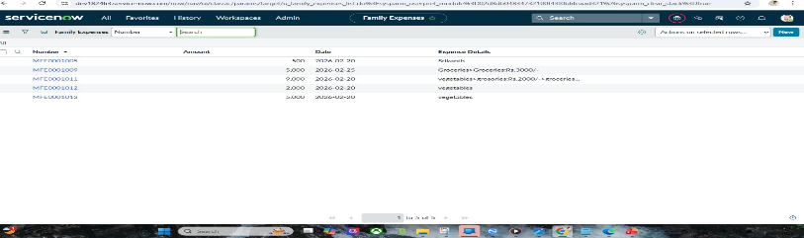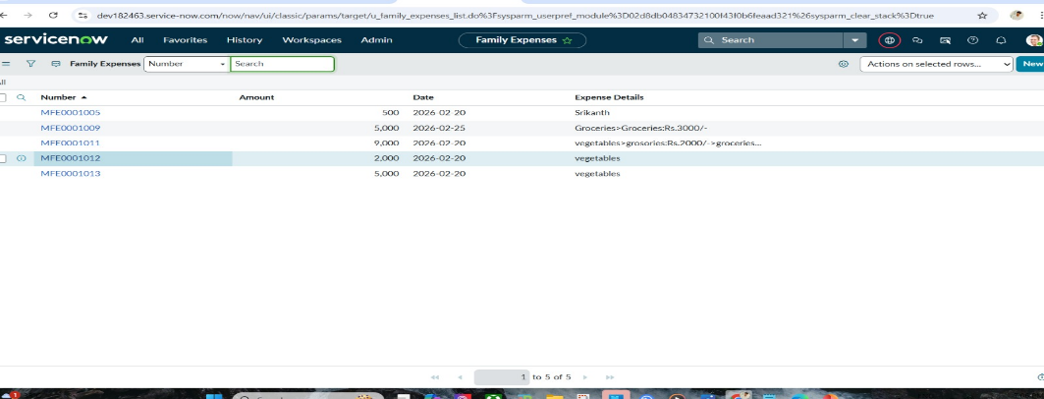
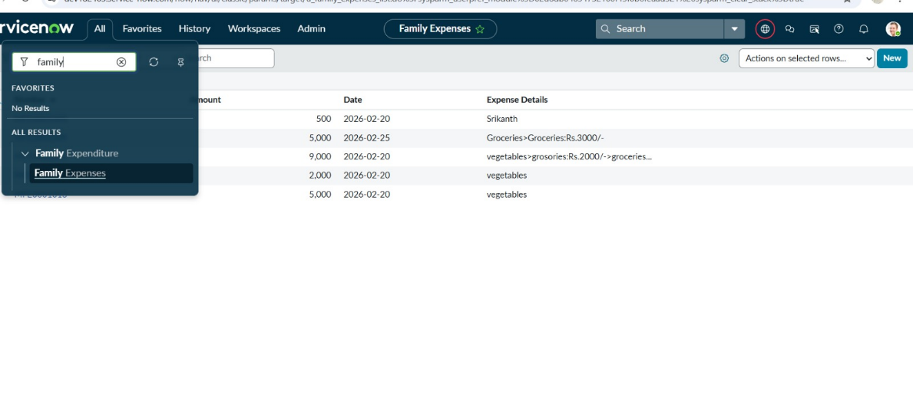

8. ADVANTAGES & DISADVANTAGES
Advantages:
- Real-time expense tracking
- Automated totals and reports
- Member-wise and category-wise filtering
- Reduced human errors
Disadvantages:
- Dependent on network for real-time updates
- Limited offline functionality
- Learning curve for first-time users

9. CONCLUSION
The Family Expense Management System improves financial visibility, reduces errors, and simplifies daily expense tracking. It empowers family members to make informed financial decisions and plan budgets efficiently.

10. FUTURE SCOPE
- Mobile application integration for easier expense entry
- Predictive analytics for expense forecasting
- Notifications for overspending or budget limits
- Integration with banking apps for automatic expense logging

11. APPENDIX
Source Code (if any): No
Dataset Link: No
GitHub Link: https://github.com/kanth7137-afk/Calculating-Family-Expenses-
Project Demo Link:
https://drive.google.com/file/d/1YqG1gwdIke-Cz8TZNoM1ts40ek2i7Evo/view?usp=drivesdk

